SUBJECT* | Lake Baldwin EUL Development Opportunity Sources Sought COR: Dustin Koonce

GENERAL INFORMATION
CONTRACTING OFFICE’S ZIP CODE* | 44131
SOLICITATION NUMBER* | 36C77626Q0281
RESPONSE DATE/TIME/ZONE | 11-30-2026 12:00 EASTERN TIME, NEW YORK, USA
ARCHIVE | 90 DAYS AFTER THE RESPONSE DATE
RECOVERY ACT FUNDS | N
SET-ASIDE
PRODUCT SERVICE CODE* | R799
NAICS CODE* | 541611
CONTRACTING OFFICE ADDRESS | Department of Veterans Affairs  Program Contracting Activity Central  6100 Oak Tree Blvd, Suite 490  Independence OH 44131
POINT OF CONTACT* | Contracting Officer  Steven Grzybowski  steven.grzybowski@va.gov  216-447-8300 ext 3584

PLACE OF PERFORMANCE
ADDRESS | To Be Determined
POSTAL CODE
COUNTRY

ADDITIONAL INFORMATION
AGENCY’S URL
URL DESCRIPTION
AGENCY CONTACT’S EMAIL ADDRESS
EMAIL DESCRIPTION

DESCRIPTION
REQUEST FOR EXPRESSIONS OF INTEREST
ENHANCED-USE LEASE DEVELOPMENT OPPORTUNITY
Orlando Healthcare System
Veterans Integrated Service Network 08 (VISN 08)
Lake Baldwin VA Medical Clinic - Orlando, FL

- Notice
This advertisement is a notice of a potential opportunity. This Request for Expressions of Interest (the “advertisement”) is not a solicitation for offers, nor is it a request for proposals. Respondents are advised that the Government assumes no responsibility to award an Enhanced-Use Lease (EUL) based upon responses to this advertisement.

- This Sources Sought Notice is to identify potential sources for information and planning purposes only and is not intended to pre-qualify or disqualify any potential Respondents.
- The purpose of this Sources Sought is to conduct market research to determine if there are responsible and qualified entities interested in redeveloping the assets described in Section III and if yes, what potential reuse options exist.
- The information gained from this Sources Sought will be used to assist the Government in determining if this development opportunity can be competitive and/or a total Service-Disabled Veteran-Owned Small Business (SDVOSB) or Veteran-Owned Small Business (VOSB) Set-Aside. The Government will use this information to determine the best acquisition strategy for this procurement and to inform related asset management decision-making.
- The Government requests that interested parties respond to this Notice with the specific information requested in Section V of this Notice and identify their small business status. VA is particularly interested in SDVOSB/VOSB respondents’ capabilities to perform a minimum of 51% of the development opportunity described in this Notice.
- Developers responding to this market research should be aware that responding to this advertisement may not ensure that they qualify for any underlying future solicitation or contract award.
- Responding to this Sources Sought Notice is NOT a prerequisite to respond to any future subsequent solicitations.
- The Government will not reimburse participants for any expenses associated with their participation in this Sources Sought.
- The Government cannot provide any warranty, expressed or implied, as to the accuracy, reliability or completeness of the information contained in this Notice.

- Overview and Objectives
The United States Department of Veterans Affairs (VA), under its Enhanced-Use Leasing (EUL) authority (38 U.S.C. §§ 8161- 8169, as amended), is seeking expressions of interest from qualified developers, including SDVOSBs and VOSBs, to serve as a “Developer” for purposes of developing supportive housing or other uses that directly or indirectly benefit Veterans (e.g., general affordable housing, skilled nursing facilities, technical job training centers, research facilities, mixed-use, other).

VA’s EUL authority allows VA to outlease land and improvements to selected developers (i.e., Lessees) to provide housing and/or other uses that directly or indirectly benefit Veterans. Such leases can have a term of up to 99 years. VA’s Office of Asset Enterprise Management (OAEM) administers the EUL Program.

An EUL is a long-term ground lease of underutilized VA-owned land or buildings to a non-federal entity (Developer). Under the EUL program, the Developer secures a long-term leasehold interest with VA for the subject property. This deal structure enables developers to finance, design, develop, renovate/construct, operate, and maintain improvements on VA property to directly or indirectly benefit Veterans.

The objective of this development opportunity is to repurpose assets at the Lake Baldwin VA Medical Clinic under VA’s EUL Program to the benefit of Veterans. Respondents should consider the following as they formulate responses to this Notice:

- Lease-back by VA or other Federal government entities is not permissible, and financing cannot reflect a lease-back arrangement. The PACT Act does not nullify 38 U.S.C. § 8162(b)(5), which states, "The terms of an enhanced-use lease may not provide for any acquisition, contract, demonstration, exchange, grant, incentive, procurement, sale, other transaction authority, service agreement, use agreement, lease, or lease-back by the Secretary or Federal Government.”
- VA may only receive cash consideration for ground lease rent in an EUL (per 38 U.S.C. § 8162(b)(3)(B)). This means VA cannot receive any in-kind consideration or free/discounted services as part of a new EUL agreement. However, projects may provide free or discounted services to individual Veterans or Veteran Service Organizations, and the Secretary may enter into an EUL without receiving consideration per U.S.C. § 8162(b)(3)(C).

Additional information on the VA’s EUL program and sample EUL projects may be obtained at: http://www.va.gov/assetmanagement/.

- Development Scope
The intent of this Notice is to determine if there are experienced developers, including SDVOSB or VOSB developers, that can develop the subject assets in accordance with VA’s EUL authority.

The Developer would undertake all necessary investigative activities to develop the selected assets at the Lake Baldwin VA Medical Clinic campus. VA is especially interested in development of supportive housing but will also consider other uses that benefit Veterans. The assets that may be redeveloped by a Developer include, but are not limited to, the following interconnected buildings (with current use in parentheses):
- Building 519 (Domiciliary)
- Building 519a (Dining / education space in the first floor courtyard)
- Building 520 (Domiciliary)
- Building 520a (Domiciliary reception / elevator space in Northwest corner of the interconnected buildings)
- Building 521 (Domiciliary)
- Building 522 (Domiciliary)

Please see Attachment A for a map of the Campus and Attachment B for asset information and photos.

- Lake Baldwin VA Clinic Background
The Lake Baldwin VA Clinic in Orlando, Florida, traces its origins to a former U.S. Navy facility. In 1968, the Navy took over an Air Force hospital in the Lake Baldwin neighborhood, opening it as Naval Hospital Orlando. By 1995, the Navy closed Naval Hospital Orlando as part of broader base closures. The facility was then transferred to VA and rebranded as the Lake Baldwin VA Clinic. VA originally used the site as part of its outpatient and transitional care network, with some portions serving as labs, treatment spaces, and administrative offices.

The 46-acre campus is located at 5201 Raymond Street, Orlando, FL 32803. The Lake Baldwin outpatient clinic offers urgent care, primary care, surgery, and specialty health services, including mental health care, laboratory services, vision care (optometry), pain management, prosthetics, physical therapy, nutrition services, homeless Veteran care, women Veteran care, and more.

- Sources Sought Response Requirements

VA is seeking qualified developers who have a proven company track record of:

- Developing projects comparable to the proposed use(s) for the designated assets.
- Financial wherewithal required to successfully develop the proposed use(s) with associated amenities (if applicable); and,
- Securing public and private financing for projects comparable to the proposed use(s) for the designated assets.

For SDVOSB/VOSB developers, VA is seeking to confirm the Respondent’s ability to perform a minimum of 51% of the development opportunity described in this Notice.

Responses should be submitted on official letterhead, must include a point of contact and the signature of at least one organization officer. Responses must address the following elements in sufficient detail to highlight the Respondent’s ability to undertake the development scope as set forth in this Sources Sought Notice. Responses must not exceed 15 pages, single spaced with a minimum 12-point font. Response content should consist of the following:

- Business Information
  - Please provide the following for your company:
- Company Name
- Address
- Point of Contact
- Phone Number
- E-mail Address
- Web Page URL
- SAM Unique Entity Identifier (UEI)

  - Based on the NAICS Code identified in the Sources Sought, please state whether your company is:
- Veteran Owned Small Business (VOSB)* (Yes / No)
- Service-Disabled Veteran Small Business (SDVOSB)* (Yes / No)
- Small Business (Yes / No)
- Woman Owned Small Business (Yes / No)
- Small Disadvantaged Business (Yes / No)
- 8(a) Certified (Yes / No)
- HUBZone Certified (Yes / No)
*If your company is SDVOSB and/or VOSB, please attach verification.

- Qualifications to Undertake this Development Opportunity
  - Corporate Overview: Provide overview of Respondent’s organization; indicate type of organization (for-profit, non-profit, etc.) and core business activities; specify age of organization; and identify leadership.
  - Real Estate Development Experience: Summarize the respondent’s real estate development experience, including product types developed (e.g., housing, mixed-use, office, parking, healthcare, etc.), infrastructure experience, number of years of experience, historic reuse experience (if any), role of entity in development, etc.
  - Real Estate Financing Experience: Summarize the respondent’s experience directly securing financing for real estate developments in the last 10 years.

- Responses to Government Questionnaire
Please include brief responses to each of the following questions:
  - What interests you about this development opportunity?
  - Which asset(s) would you be interested in redeveloping?
  - What use(s) would you contemplate developing and how would the use(s) benefit Veterans? Please be as specific as possible.
  - What sources of non-VA financing exist for the proposed use(s) for this project?
  - What concerns, if any, do you have about this development opportunity?
  - What specific information about the asset(s) and/or EUL development opportunity would you like to see included in any future Request for Qualifications (RFQ) regarding this opportunity?
  - Is there anything else that you wish to share with the Government with regard to this development opportunity? For example, is there something the Government should include in the RFQ that would make this development opportunity more attractive?

- Deadline to Submit Questions regarding Notice
All questions regarding this Notice should be submitted via email to Dustin Koonce, at Dustin.Koonce@va.gov 10/28/2026. Questions will be answered as an amendment to the advertisement.

- Deadline to Submit Responses to Notice
If your organization has the qualifications set forth in this Notice and is interested and capable of executing all aspects of this opportunity, please email your response as an attachment to Dustin Koonce, at Dustin.Koonce@va.gov 11/30/2026.

Attachment A: Campus Map
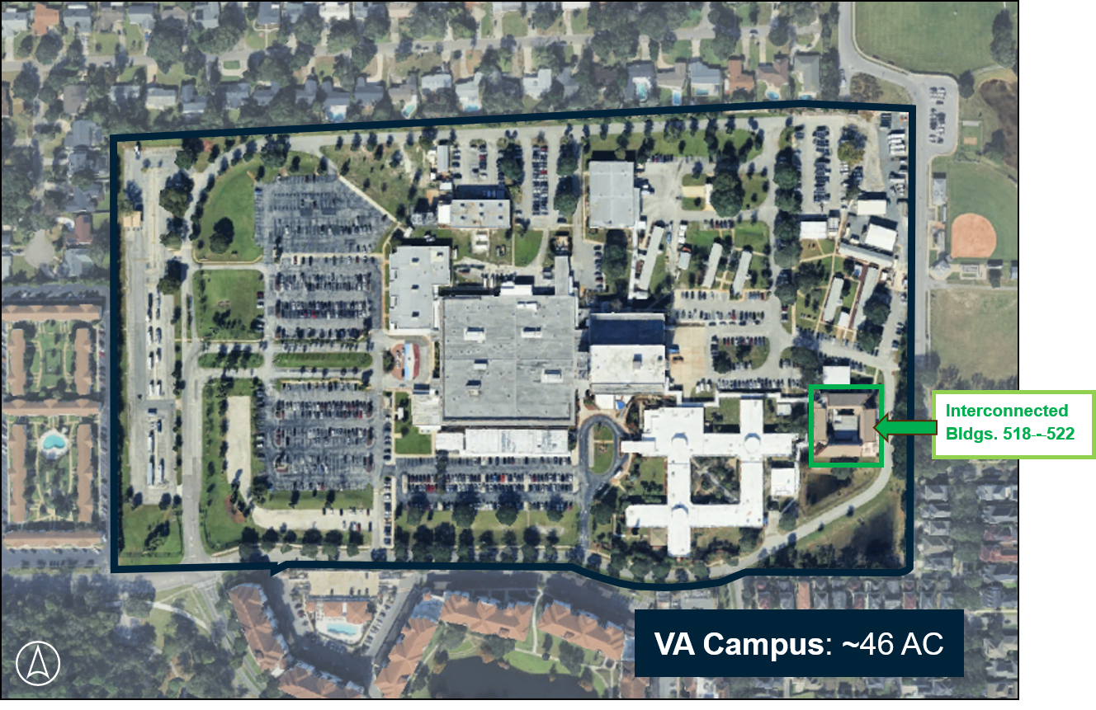

Attachment B: Asset Information, Photos, and Floorplans
Asset Information
Building  Key Characteristics | B519 | B519a | B520 | B520a | B521 | B522
Square Footage (GSF) | 6,595 GSF  (3-story building) | 2,500 GSF  (1-story) | 5,565 GSF  (3-story building) | 3,816 GSF  (3-story) | 6,566 GSF  (3-story building) | 5,565 GSF  (3-story building)
Current Use | Domiciliary | Dining / Education | Domiciliary | Domiciliary reception / elevator | Domiciliary | Domiciliary
Year Built | 1987 | 1987 | 1987 | 1987 | 1987 | 1987
Historic Status | Not Historic | Not Historic | Not Historic | Not Historic | Not Historic | Not Historic
Environmental Issues | - FEMA 100-Year Floodplain: No  - Wetlands: No  - Critical Habitat: No  - Superfund/Brownfields: No
Utilities | Power, water, and sewer are currently connected to the VA campus infrastructure. Utility separation is feasible.
Access and Road Infrastructure | Access to buildings and is available from Raymond Street and internal VA campus roadways.

Attachment B: Asset Information, Photos, and Floorplans (cont’d)
Building Photos | Description
Building 519
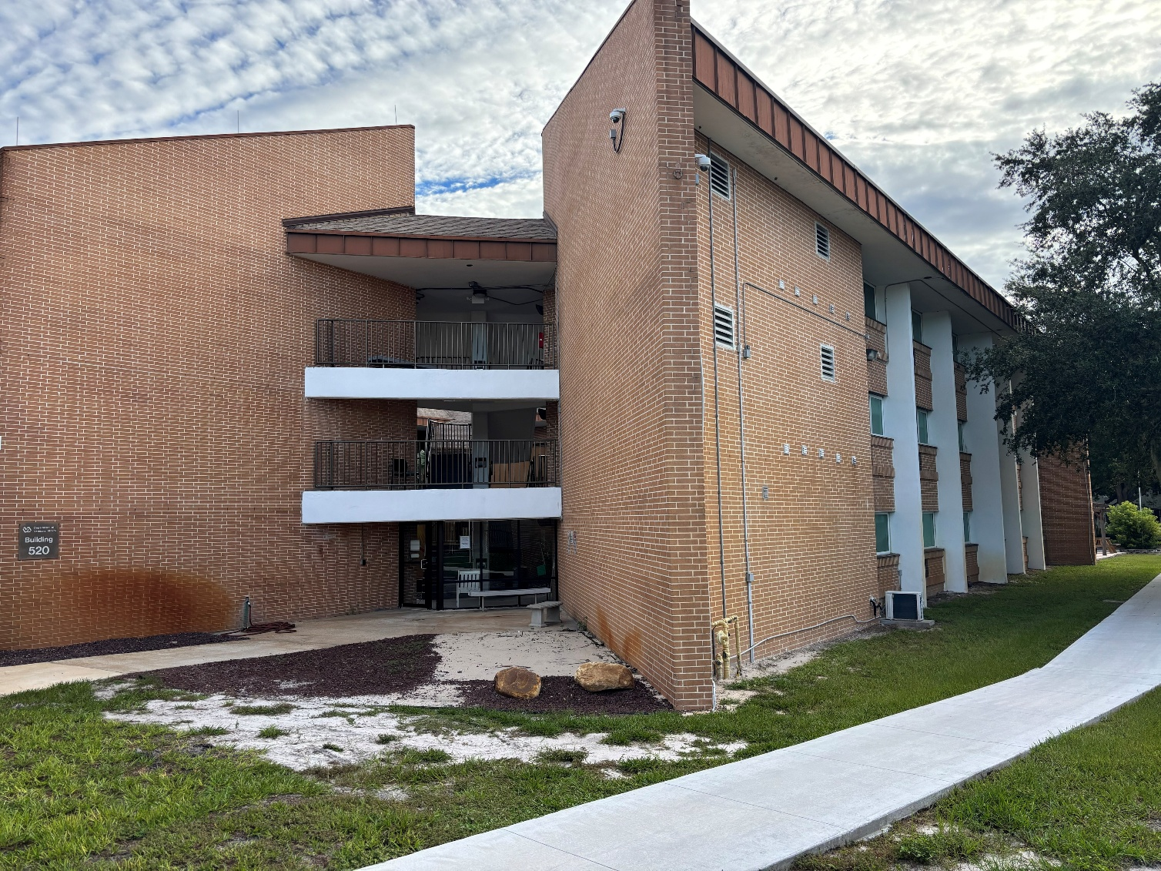 | Exterior (520 and 519)
Building 520
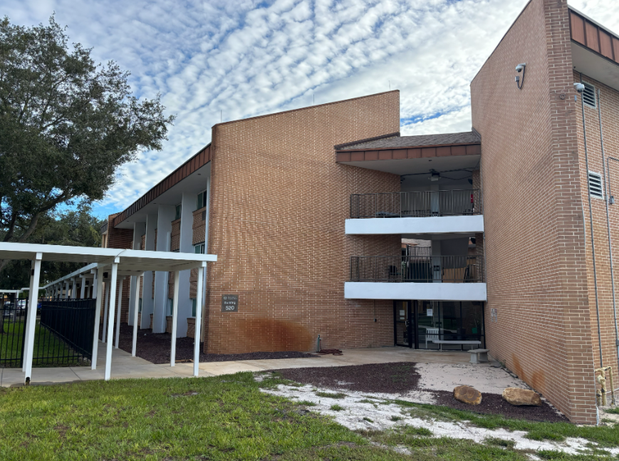 | Exterior (B520 and 519)
Building 521
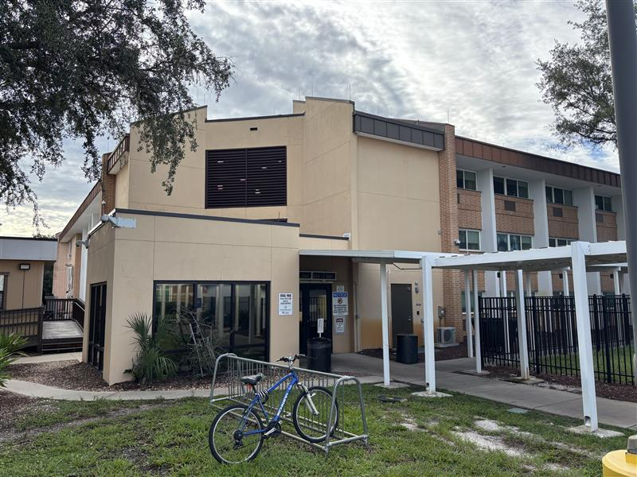  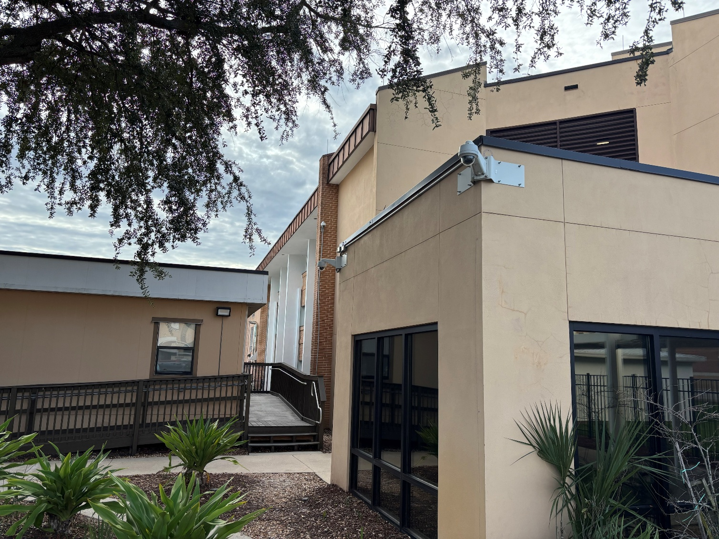 | Exterior (B521)  Exterior (B521)
Building 522
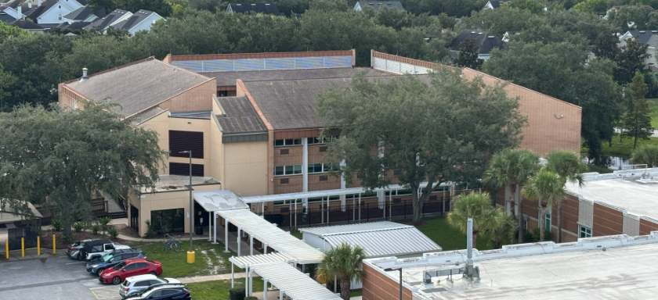 | Exterior – Central Building not visible within courtyard.

Attachment B: Asset Information, Photos, and Floorplans (cont’d)
General Floorplans and Elevations | Description
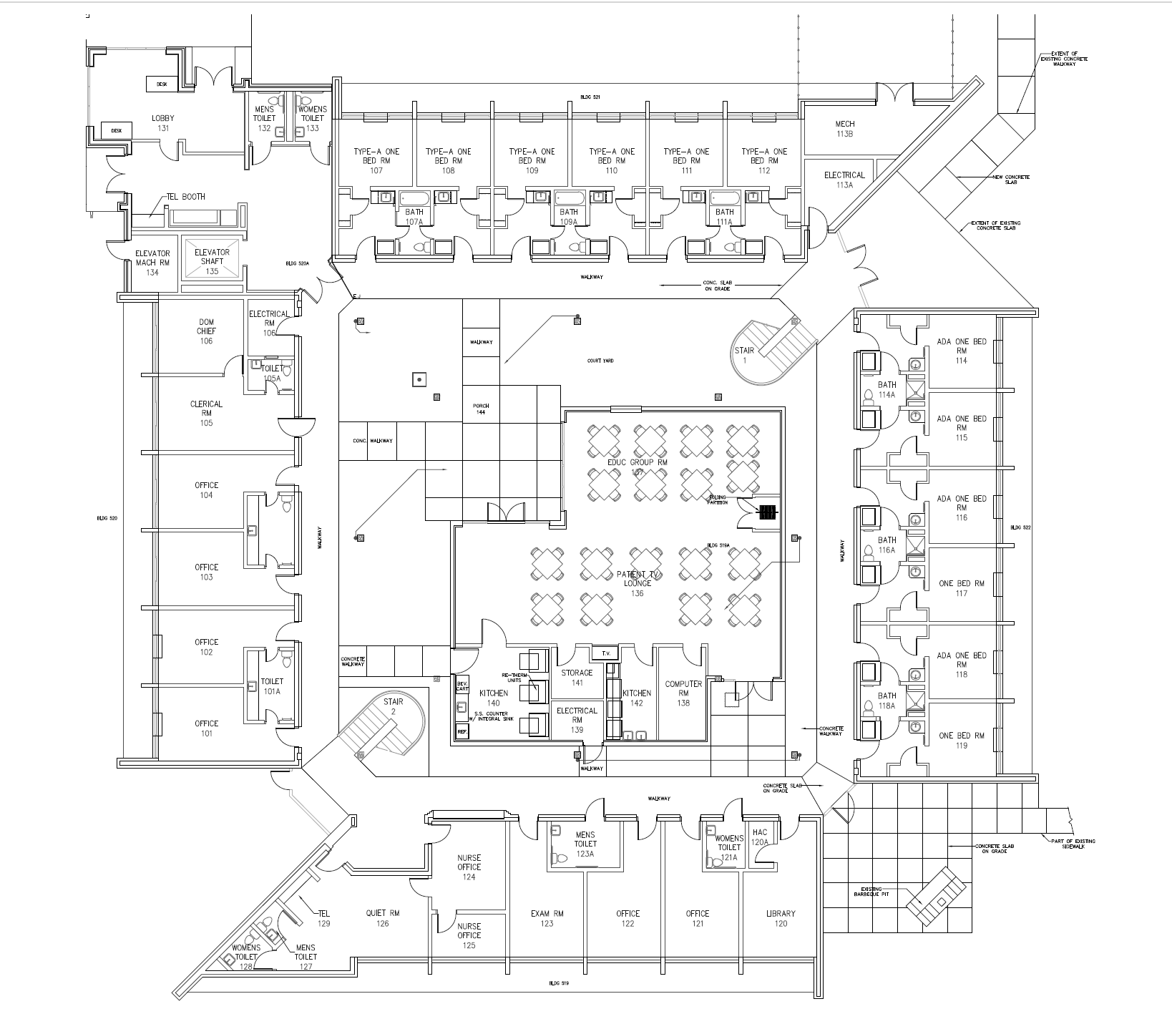 | General Floorplan  (Floor 1)
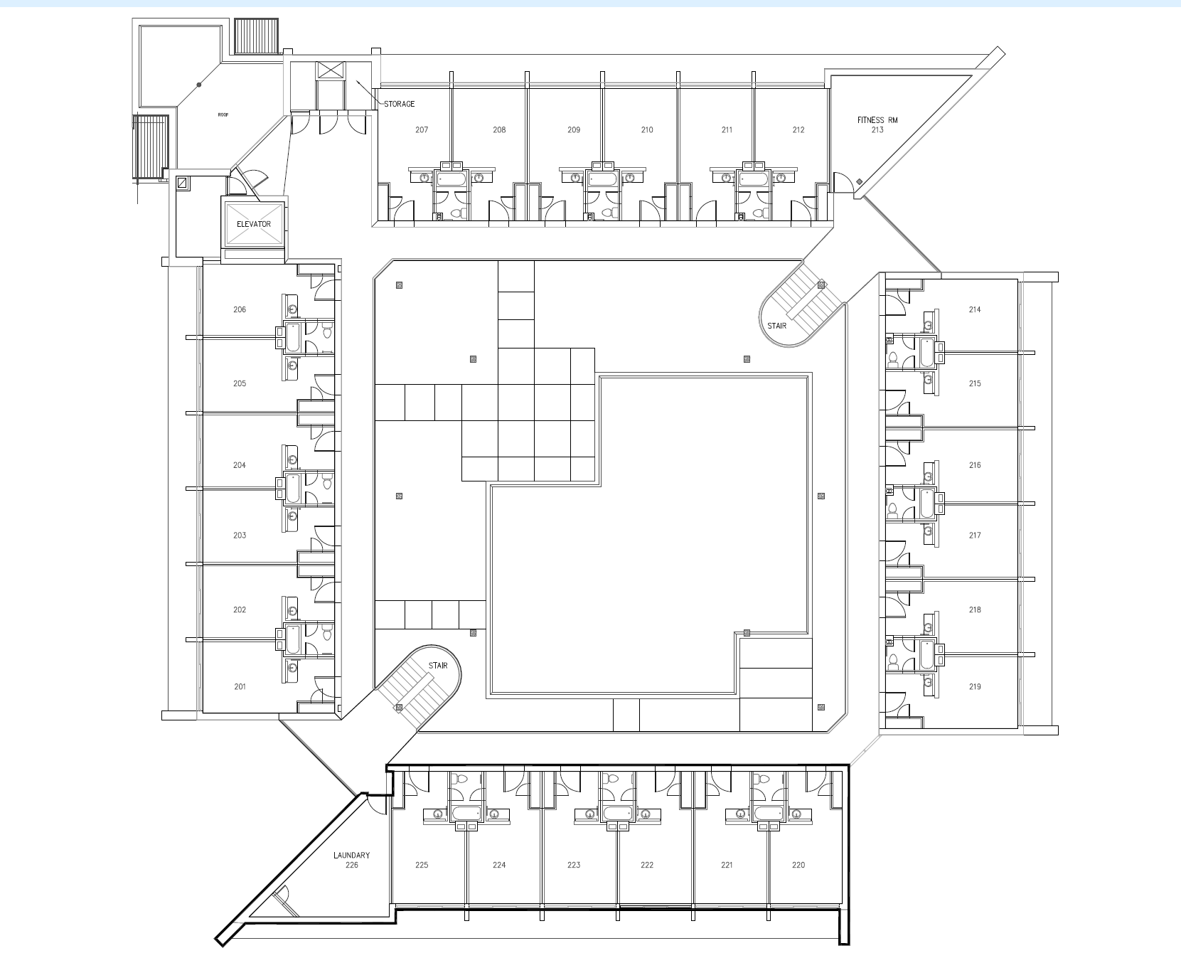 | General Floorplan  (Floor 2)
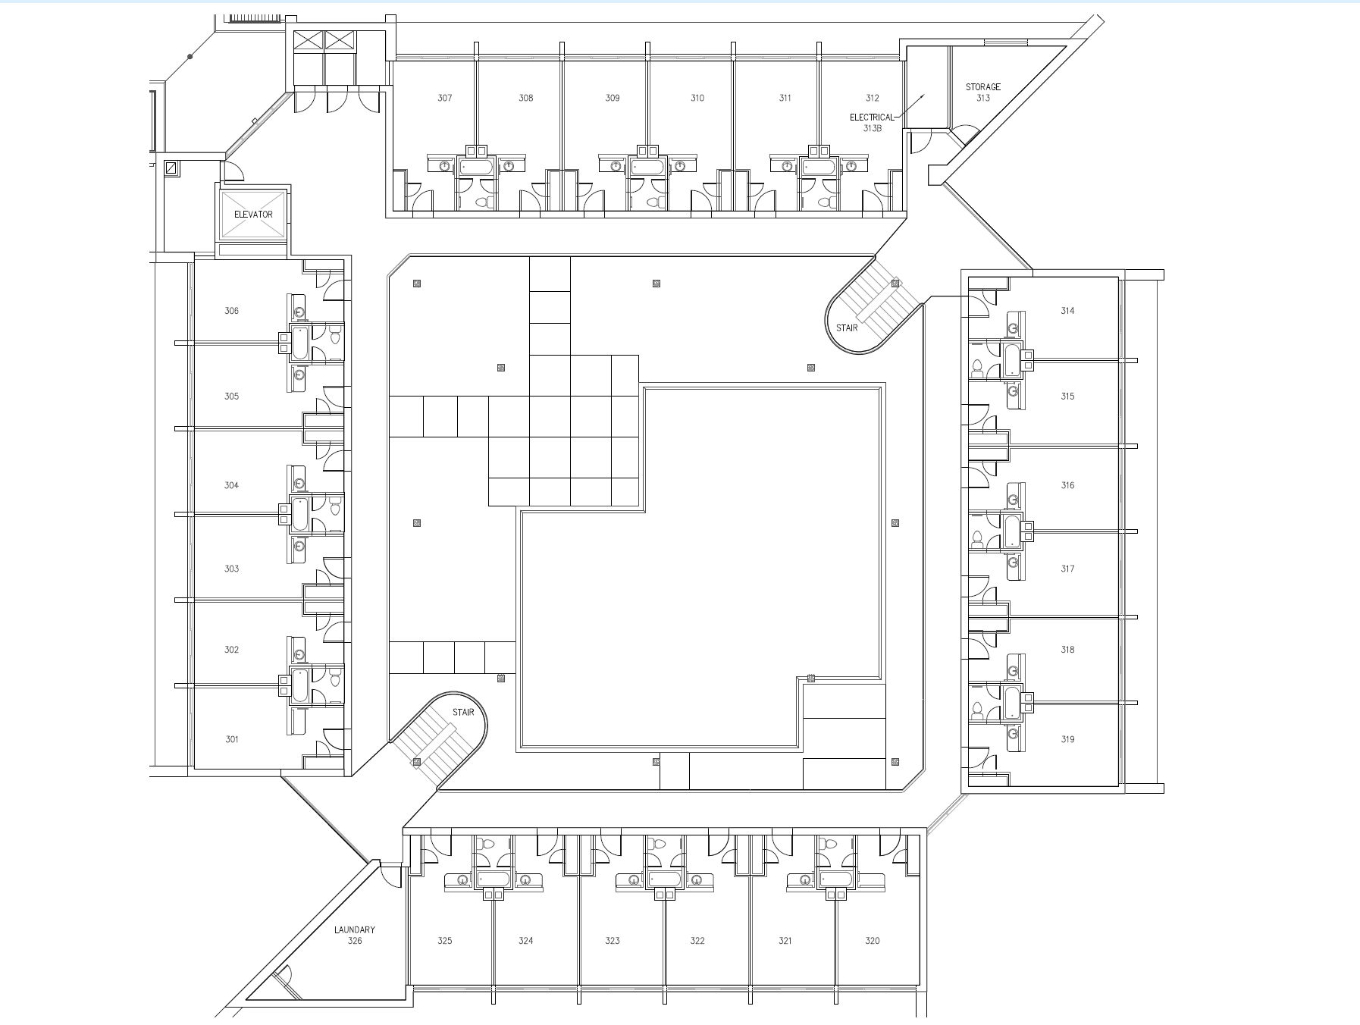 | General Floorplan  (Floor 3)
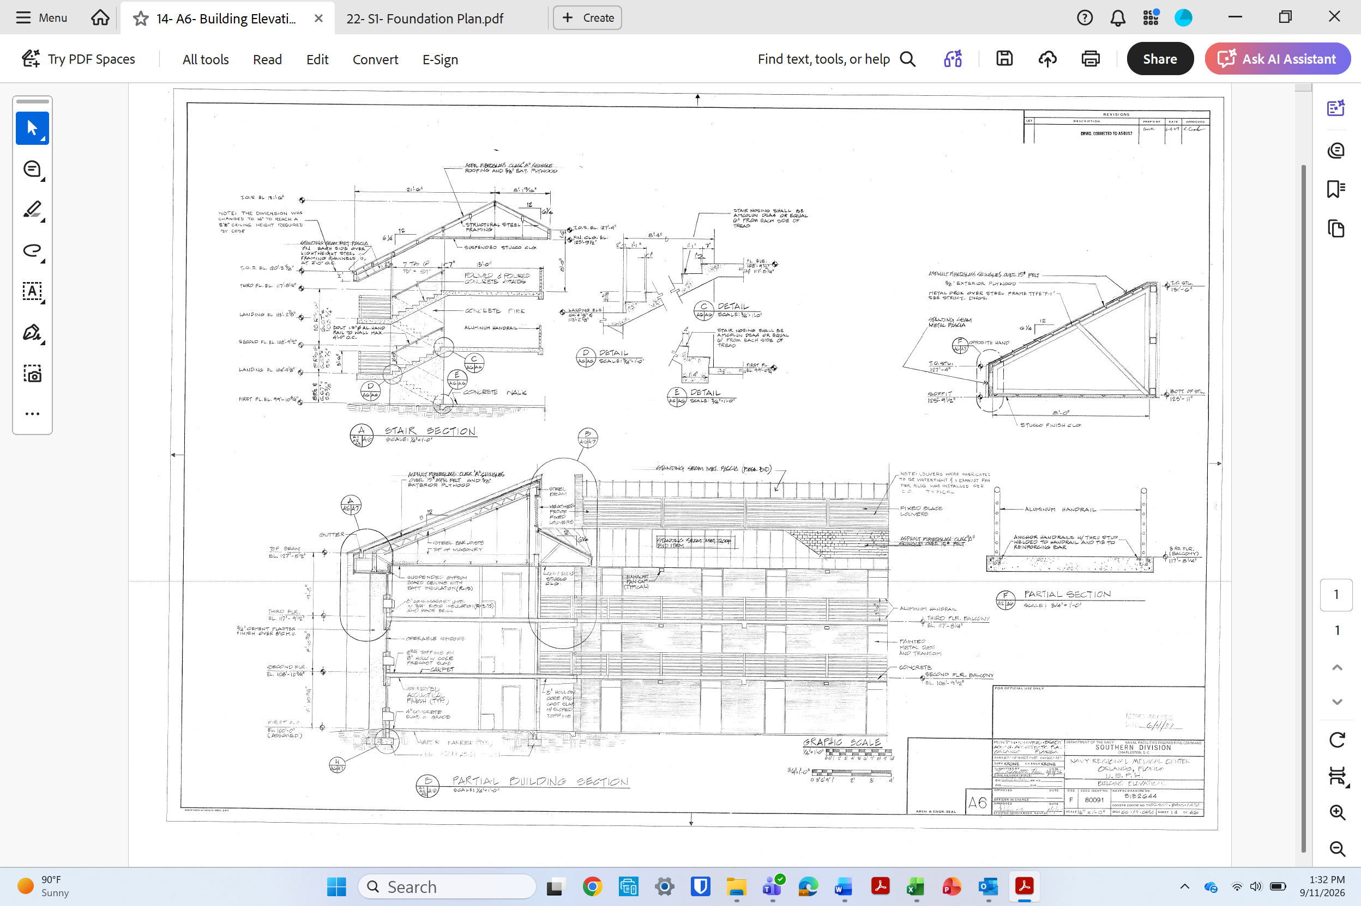 | Elevations
 | Foundation Plan

End of Document

